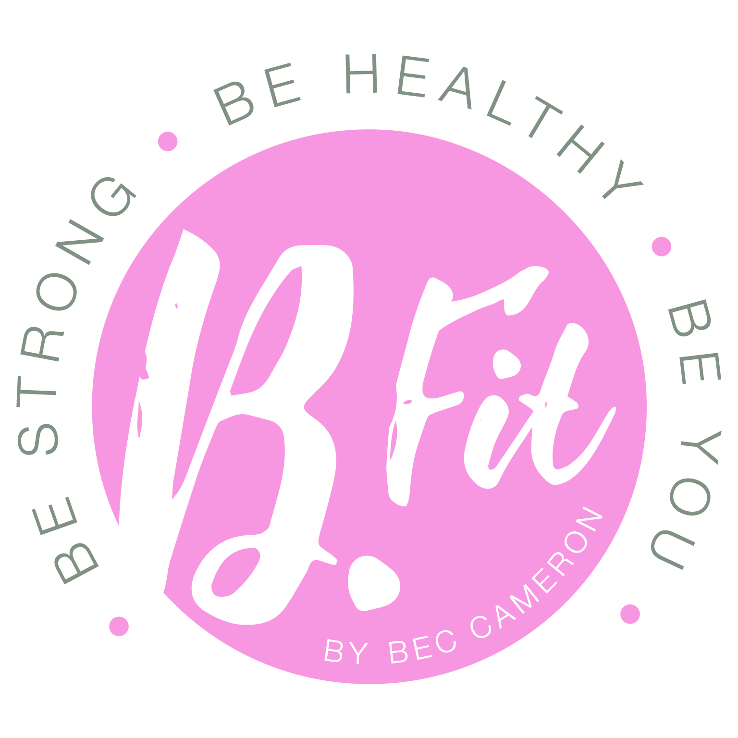
BFIT BESPOKE TERMS AND CONDITIONS

Thank you for your interest in signing up to a Bespoke B.Fit Program!

Please take the time to read through these supplementary terms and conditions (“Bespoke B.Fit Program Terms”) which, in conjunction with my main terms and conditions (“Website Terms” which, together with the Bespoke B.Fit Program Terms are the “Terms”) will constitute a binding agreement between you and B.Fit by Bec Cameron (ABN 15 312 752 939) (“B.Fit”, “us”, “our”, “we”) with respect to your Bespoke B.Fit Program. A copy of the Website Terms are annexed to these Bespoke B.Fit Program Terms.

If you do not agree with any of these Terms, please do not submit a Bespoke Order. By placing a Bespoke Order, these Terms will constitute a binding agreement between us.
Capitalised terms which are used in these Bespoke B.Fit Program Terms and which are undefined have the same meaning ascribed to them in our Website Terms.
1. Your Obligations
  - You are required to check in via email each week at the time specified. This enables us to respond to you in time in case any changes are necessary for the following week. If check ins are sent late, then our response to you may be delayed.

  - You are required to take progress photos before you begin your Bespoke B.Fit Program and every 2-4 weeks of your journey (“Progress Photos”). Please send your Progress Photos to us at bec@bcbfit.com.au along with your check in so that we can monitor your progress.

  - If you are posting any updates or photos of your fitness journey on social media, regardless of the form of content (e.g. Video, photo, blog, post etc) please credit to Bec Cameron and B.Fit by Bec Cameron. These posts may include updates in relation to your progress, transformation, change in body composition, achievement of fitness oriented goals, your meal preparations, and training sessions prepared and/or completed. Credit can be made by tagging @bec_bfit on Instagram and B.Fit by Bec Cameron on Facebook. You may also use the hashtag #BFitBodies.

- Our Obligations
  - We will endeavour to respond to all questions as promptly as possible, but please understand that as a sole operator who also operates a personal training business training clients on a daily basis, we may not always be able to respond immediately.

  - We endeavour to provide a response to emails within 48 hours. If you have an urgent enquiry, please text 0438016543.

- Payments and Freezes
  - If you have purchased a “Nutrition and Training” Subscription Payment Bespoke B.Fit Program, you authorise us to deduct direct debits of AU$55 inc GST every week, plus a once off AU$50 start-up fee.

  - If you have purchased a “Nutrition Only”, Subscription Payment Bespoke B.Fit Program, you authorise us to deduct direct debits of AU$45 inc GST every week, plus a once off AU$40 start-up fee.

  - All direct debits will be deducted from your nominated credit card or bank account and are managed by a third party payment gateway, Quickpay (www.quickpay.net.au). Please read the terms and conditions for Quickpay (insert link to their terms and conditions)

  - Direct debits will be automatically deducted during your Minimum Training Period and cannot be cancelled. However, if you become sick for longer than a week or become injured, then so long as you have provided us with a medical certificate, your Minimum Training Period may be suspended for such period which your medical practitioner advises provided that such advised period is clearly specified on your medical certificated. Please submit your medical certificates to bec@bcbfit.com.au

  - If you are intending to go on holidays and do not have access to adequate facilities, you may also suspend your Minimum Training Period for up to an aggregate period of three (3) weeks by providing us with 15 days’ notice in advance. Requests to suspend your Minimum Training Period for holiday reasons can be submitted or made by contacting bec@bcbfit.com.au

  - We will use all reasonable endeavours to suspend any direct debits for the suspended period during your Minimum Training Period (“Suspended Period”). However, in the event that we are unable to do this in time, the amount debited for a Suspended Period will be carried over to your next direct debit, and the next amount deducted as your direct debit will be altered accordingly.

- Use of Progress Photos
  - We may share your Progress Photos on social media and/or our other marketing materials (including on our website). We will advise you when we are intending to use your Progress Photos beforehand and you may elect to remain anonymous and/or have your face hidden in to protect your identity if you wish. We will always let you know if we are intending on using your Progress Photos so you have a chance to let us know if you wish to remain anonymous and/or have your face hidden. If you do not respond to us, you agree that we may automatically hide your face and upload your Progress Photos without further notice to you (provided you are not named).

- Disclaimer and General
  - You acknowledge and agree that you have read our Website Terms, a copy of which are annexed. In particular, you acknowledge that you have read, reviewed and understand the disclaimers set out in clause 4 of our Website Terms. The Terms will constitute the entire agreement between you and B.Fit.

  - Any provision of these Terms which are void or unenforceable may be severed without affecting the enforceability of any provisions.

  - These Bespoke B.Fit Program Terms and our Website Terms will constitute the entire agreement between us with respect to your Bespoke B.Fit Program and supersede any other prior agreements.

  - We reserve the right to make changes to the Terms. We will endeavour to notify you of any changes to these Bespoke B.Fit Program Terms by sending you a notice via email, and any changes to the Website Terms by placing a notice on our Website. The prices of a Bespoke B.Fit Program may, from time to time, also change. Where you have purchased a Subscription Payment Bespoke B.Fit Program, we will notify you of any changes to your subscription fee(s) by sending you a notice via email. However, any amounts you have paid upfront and/or which are subject to a Minimum Training Period will be fixed for that applicable period.

  - These Terms are governed by the laws of the State of Victoria, Australia and you agree to submit to the exclusive jurisdiction of the courts of such State in resolving any disputes, claims or controversies.

Print name:
Signature:

Date:
Date of Birth:

Where the individual being trained under the Bespoke B.Fit Program (“Participant”) is under the age of 18, I warrant that am the parent or legal guardian of the Participant and consent and agree to these Terms with respect to my child.

…..………………………………………..…...................................

Signature of Parent / Legal Guardian

…..………………………………………..…...................................

Name of Parent / Legal Guardian

…..………………………………………..…...................................

Address of Parent / Legal Guardian

WEBSITE TERMS
[insert hyperlink]

